Romsey Mill’s Young Parents Programme
2018-2019

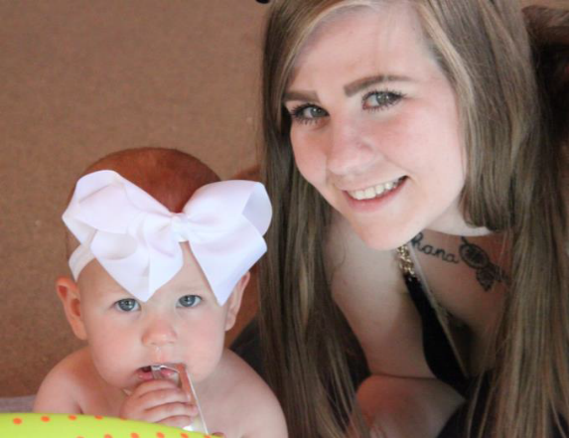
Romsey Mill’s Young Parents Programme began in 1998 and has been supporting teenage parents for over 20 years. We are the leading provider of services for teenage parents in Cambridge City and South Cambridgeshire. We provide intensive personal, social, educational, health and parenting support, equipping teenage parents and their children for positive futures. Activities include home-visiting and one-to-one support, antenatal courses in partnership with health colleagues; parenting advice; courses to develop learning and skills, mental health and wellbeing support; advice about Early Years education and childcare; employment, housing, training and benefits advice. Our work is long term, relational, needs-led, and evidence-based, keeping the family at the centre.
We believe strongly that young parents are more likely to respond positively to support which is tailored specifically to them:
“In too many cases: there had been insufficient support for young parents. Young teenage parents need to be supported in an environment in which they feel comfortable and supported. Adult centred services may not achieve this without additional teenage focused services.”
Alison Hadley,
Director, Teenage Pregnancy Knowledge Exchange,
University of Bedfordshire
Antenatal support
We deliver an 8-week rolling antenatal programme for mothers and fathers in conjunction with midwifery. These courses are very relational, practical and cover all aspects related to pregnancy and birth. We seek to respond to the needs, concerns and questions of the individuals who attend, so each course is modified and adapted to the group. During 2018-19 we delivered 4 courses with 20 mothers and 13 fathers attending. A highlight of each course is the visit to the Rosie Birth Centre as it enables parents to build confidence and reduce anxiety over the birth of their child. Camquit and Brazelton have both partnered with us and delivered specialist sessions for young parents.

Everyone’s so kind and lovely! And have supported both me and my boyfriend through my pregnancy and have helped with any issues we’ve had with housing, it’s also nice to attend every Friday as the antenatal sessions really help and build up my confidence as a mum to be as I have learnt so much that I may not have already known, and also the extra nights they’ve had that me and my boyfriend have attended for example “scrapbooking” and “games night” (for young dads) as it gets us out of the house and we really enjoy coming along! Also interacting with other young mums in the same situation that you’re in.

Breastfeeding
We embed breastfeeding support within antenatal, Babies and Buddies and 1:1 support and guidance. We have provided support and information to parents on the health benefits of breastfeeding. Over the last 3 years we have seen an increase in the number of mothers who have initiated breastfeeding. During 2016/17 65% of the mothers supported by YPP initiated breastfeeding, this figure rose to 77% during 2018/19. The number of mothers who have breastfed for more than 3 months has also increased significantly from 21% in 2016/17 to 46% in 2018/19.

First Aid
Once a term we hold first aid training for young parents delivered by ABC First Aid. This is a positive partnership as the trainer delivers it for free of charge for our young parents. During 2018/19 a total of 26 parents have been trained in basic first aid (16 mothers and 10 fathers).

Social care advocacy support
It’s really important for parents to feel supported through the Social Care process. Most young parents struggle to understand what is happening around them and so the Romsey Mill staff act as advocates and help parents navigate the procedure. All the team attend and contribute to Social Care meetings. The team will contribute to discussions in the meetings, help set goals and explain how Romsey Mill can assist in any plans.
Social Care recognises the work of the Romsey Mill’s Young Fathers Worker as an important factor in positively engaging young dads where either a CIN or CP plan is in place.

Domestic Abuse
The Young Parents Programme team, including the Young Fathers Worker, offer and provide support for those who identify themselves, or who had been identified by other agencies as being a perpetrator or victim of domestic abuse. Some young parents are much more willing to discuss these issues on a one-to-one basis and we can refer them to other agencies for additional support.
Domestic abuse and mental health are the two key contributors to social care intervention. During 2018/19 32 young mothers have been supported in relation to Domestic Abuse.
Mental Health work
Romsey Mill’s staff members have completed Mental Health First Aid training and additional training in order to provide support to young parents experiencing a range of mental health related issues including postnatal depression, anxiety disorders, bipolar disorder, personality disorders, depression, eating disorders, obsessive-compulsive disorder and self-harm. Romsey Mill’s YPP team regularly helps parents requiring counselling or other therapeutic support and the team engages with CAMHS and the Perinatal Mental Health Team. During 2018/19 The YPP team have supported 29 mothers with mental health challenges.

Five to Thrive
Respond – Cuddle – Relax – Play - Talk
Five to Thrive is a simple concept which helps parents to understand five things to do with their child each day to promote healthy brain development. We continue to introduce parents to Five to Thrive in antenatal, baby groups and 1:1 support and utilise the resources that we have developed.

Babies and Buddies post natal group
Five to Thrive, baby essentials and EYFS (Early Years Foundation Stage) are embedded into our post natal support group. This group runs weekly for 2 hours. Camquit, Dhiverse (Sexual Health) and the CAB have all attended and given specialist support. 35 mothers aged 19 and under, with a further 7 additional mothers (over 19) have attended Babies and Buddies or other postnatal groups such as scrapbooking during 2018/19.

My Romsey Mill worker is very warm, very helpful and really makes me feel at ease. I really like her approach and the encouragement to attend groups etc.

Family events, trips & activities
Each year we encourage both mothers and fathers to attend our family friendly events, trips and activities. These activities encourage both parents to spend time with their children as a family and grow positive parenting relationships.

Romsey Mill not only helped me and have me confidence but also gave me a new look on life, I always thought I was the only one in my situation, turned out I wasn’t! I met other young parents then I would of never met if I didn’t attend Romsey Mill! We’ve made friends that we still talk to now! I couldn’t thank Romsey Mill and the staff for everything they’ve done for us, my daughter’s starting the nursery this current September and I’m so excited knowing she’s going to be in a safe and loving environment! As that’s what Romsey Mill provides us with when we attended classes. Romsey Mill also taught us life lessons and ways to cook by holding cookery groups that I very much enjoy, they’re also so trustworthy and you can talk to them about everything and knowing it stays between you and the staff. The days out that are provided we’re an amazing extra showed us that we can have fun without having to spend loads of money! Shepreth was definitely my fav trip!

Educational courses
Young mothers attend educational courses run by the programme. These are delivered through a sub-contracted arrangement with Adult Learning and Skills with additional funding from Cambridge City Council’s Community Development Fund, from Cambridge United Charities, and from Romsey Mill’s individual and community fundraising. These courses create an opportunity for young mothers to get use to using childcare (which is provided on-site), to re-engage with learning and gain qualifications. During 2018-19 we delivered a 10 week ‘Improving confidence in English’, SHINE a self esteem and confidence building course (10 weeks) and a Bronze Arts Award (10 weeks) in collaboration with the Fitzwilliam Museum. The children are looked after in an adjacent room to the parents and for many this is their first experience of using childcare. Transport, lunch and lots of one-to-one support are also provided in order to encourage young parents to attend. Having gained confidence in learning on a short course in a supportive environment, many young parents choose to continue their education by starting a full-time/ part-time college course or work.

Fathers’ positive activities & life coaching
Fathers are invited and supported to attend activities (such as golf, gaming, boxing, cardio workouts) without their children. The activities serve the purpose of introducing them to a new activity with the opportunity to receive encouragement and helping to increase their confidence. During the sessions the Young Fathers Worker has been able to discuss a range of issues including:
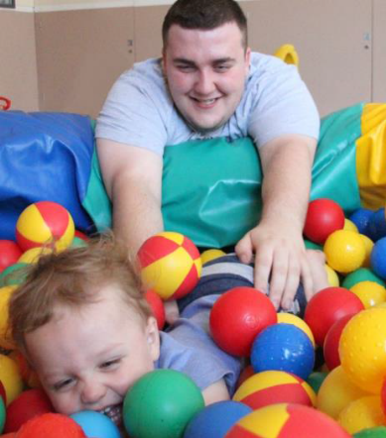
- Anger / violence
- Suicide
- Healthy Relationships
- Abusive relationships
- Father and son relationships
- Parenting apart
- Step parenting
- Removal of children

Three young fathers have been supported to volunteer within the Romsey Mill charity shop. Two of the young fathers focused on putting items on ebay while the other worked within the shop itself serving customers and sorting through donations. All have grown in confidence as a result but one young father developed the necessary skills to get full-time employment.
My experience with Romsey Mill I have had a lot of help with contact with my child and also looking for jobs, looking for baby courses and have been all around very helpful.

