CONTENTS
1 Introduction to the Almshouses p 2

2 Terms of Occupancy p 4

3 Services Provided in the Almshouses p 9

4 General Information p 13

5 Complaints Procedure p 15

6 Useful Addresses and
Sources of Information p 17

1 INTRODUCTION TO THE ALMSHOUSES
Welcome! You have become a resident in an almshouse owned by the United Charities of Cambridge (UCC).
What is an almshouse? An almshouse provides accommodation for people with limited means and is usually owned by a charitable organisation. In legal terms, the people who live in an almshouse are called residents or beneficiaries. They are not tenants like people in social housing. They do not pay rent but a Weekly Maintenance Contribution (WMC) towards the services provided.
What is the United Charities of Cambridge? It represents an amalgamation of several charities that were formed to manage the properties and money left to the people of Cambridge by several local philanthropists since the 17th Century. The Charity is run in accordance with its Governing Scheme by twelve voluntary Trustees. (More about UCC on www.unitedcharitiesofcambridge.org).
.
The almshouses: UCC own twenty-eight one-bedroom unfurnished almshouses which are available to people on a low income who have lived in Cambridge for at least two years and are normally over 50 years of age. The almshouses are located in Church Street Chesterton, King Street, John Street and St Anthony's Walk. Their day-to-day management is carried out by the Hundred Houses Society (HHS), a local Registered Social Landlord which operates many properties in the city. HHS has appointed a Housing Officer who helps and advises the residents of all our almshouses. In case of problems, this is the person you should try and contact first. (More about HHS on www.hhs.org.uk ).

Each set of almshouses has a Visiting Trustee who keeps in touch with residents and reports back to the Almshouse Trustee. An Almshouse sub-Committee meets regularly to monitor the services provided by HHS and to advise their fellow Trustees when making decisions concerning the almshouses.

All the almshouses are unfurnished flats, and many of them have been adapted over the years for the needs of older people. The Trustees hope that residents will enjoy many years of independent living in a comfortable, safe and friendly environment.

CONTACTING THE CHARITY
Your Visiting Trustee is

Your HHS Housing Officer is

2 TERMS OF OCCUPANCY
Moving In
You will be given a copy of the Letter of Appointment, which you sign when you are appointed as a resident. This is your Licence to Occupy. It is an important document which includes the Regulations which apply to residents. Please keep it safe.

Rights and responsibilities
As a beneficiary of United Charities of Cambridge you have a number of rights. These include the right to live peacefully in your home and to have certain repairs carried out. You also have responsibilities, namely to pay your weekly maintenance contribution, to look after your property and to be a good neighbour.

Financial responsibilities
New residents are requested to pay the Weekly Maintenance Contribution (WMC) which is calculated weekly but our preferred method of payment is monthly by Direct Debit. Simply phone HHS with your bank account details and they will do the rest. Should there be a need for you to open a bank account, then HHS can help you to organise this. If, for any reason, direct debit does not work for you, HHS can advise you of other methods of payment.
You will be given a minimum of one month’s notice of any increase in the WMC which is usually reviewed with effect from April 1st each year.
The amount you pay covers part of the cost of running the almshouses and includes:
- water and sewage charges ,
- gas central heating and hot water,
- upkeep of the gardens,
- repairs and maintenance as detailed in this Handbook,
- cleaning and lighting of communal areas,
- insurance of the building but not of your furniture and possessions,
- provision of the Community Alarm Call System (if required).

Each resident is responsible for their own Council Tax. This is paid to Cambridge City Council, who can advise on methods of payment and financial help available. The Housing Officer will be able to advise you if you are unsure of your entitlement and can help you to obtain and complete any application forms.

Each resident is responsible for their own electricity bills. Please consult HHS regarding the current supplier arrangements.

Television licences
Our residents need to apply for their own TV licences. If you have any problems with the Licensing Authority please contact the HHS Housing Officer.

In cases of genuine hardship, the Charity might consider assistance with the TV licence fee. This will be dealt with on a case by case basis. Please contact your Visiting Trustee in the first instance, should this apply to you.

Please be considerate. TVs, radios, stereos and musical instruments which are too noisy can be a great nuisance to neighbours.

Visitors
If you wish to have a relative or friend to stay for more than seven consecutive nights, please notify HHS in advance. HHS needs to know who is in the almshouses for the safety and security of the whole community.

In March 2019 the Trustees decided to use 127 King Street as guest accommodation for residents of the UCC almshouses. This is administered by HHS and there is a modest charge for this service.

Lodgers and Sub-Letting
You are not permitted to have lodgers or to sub-let any part of your home.

Running a Business
You are not permitted to run a business from your property.

Pets
Some types of small animals or caged birds may be acceptable but must not become a nuisance to other residents. If you wish to keep a pet you must first obtain the written permission of the Charity. Application for permission should be made via HHS.

Harassment, Discrimination and Violence
The Charity will not tolerate any form of harassment, discrimination, or violence. This includes violence or threats of violence to friends, relatives, neighbours, staff, contractors or agents while they are carrying out their work. The Charity may seek to evict you if you commit an act of harassment, discrimination, or violence.

If you are a victim of harassment, discrimination, or abuse you should contact HHS immediately. Allegations of racial and sexual harassment are taken very seriously and prompt action to investigate and respond will follow. Legal action will be taken against anyone guilty of harassment, discrimination, or violence. The Charity has adopted the HHS equalities policy, a copy of which is available from the HHS office.

Moving Out
If you wish to leave your almshouse you must give the Trustees written notice of at least 28 days. During this notice period you will be liable for your Weekly Maintenance Contribution (WMC) payments even if you have already moved out. Residents or, in the event of death, their personal representatives, are responsible for WMC until the premises are cleared of personal possessions and the keys are returned.

Asking you to move out
The Trustees may ask a resident to find alternative accommodation in certain exceptional circumstances:
- If you do not comply with the rules set out in your Letter of Appointment or on notices displayed in your almshouses. These rules are for the benefit of all residents and will be explained by the Housing Officer when you take up your Licence to Occupy. Please comply with them.
- If you are no longer eligible to live in the almshouse. For example, you could win or inherit a significant sum of money.
- If you are no longer able to look after yourself. Even with the help of your family and Social Services, there may come a time when this is putting yourself and/or your neighbours at risk.

The Trustees will only ask you to move out as a last resort, after a fair process of investigation and warning. They will give you as much time and help as possible to find alternative accommodation.

3 SERVICES PROVIDED IN THE ALMSHOUSES
Fixtures and fittings
The following equipment and systems installed in the almshouses are maintained in working order by Hundred Houses Society (HHS) on behalf of the Trustees: Boilers, hot water systems, washbasins, baths, toilet fittings and kitchen units.

On the other hand, floor coverings and white goods like cookers and refrigerators are the responsibility of the resident.

UCC Hardship Grants
The Charity manages a Hardship Fund which can in certain cases of financial hardship help a resident with the costs of moving into an almshouse, e.g. for buying a fridge or cooker, pieces of furniture, a carpet (or other essentials). Please get in touch with the Almshouse Trustee if you are in financial difficulty.

Heating
Central heating has been installed to keep you warm and comfortable in your home, but you should be able to turn your thermostats up and down to avoid wasting heat. Heating bills are paid by UCC. If you are not warm enough, please contact the HHS Housing Officer, but remember that freestanding electric, paraffin or gas heaters are NOT allowed, as they are dangerous.

Cleaning and decorating
The UCC are responsible for
- external and internal repairs to the almshouses,
- external decoration of properties and internal decoration of communal areas,
- external window cleaning and internal window cleaning in communal areas.

Residents are responsible for keeping the inside of their almshouses in good order, including
- internal decoration and floor coverings,
- internal cleaning, including windows (using suitable non- abrasive cleaning materials on floors, walls and kitchen units),
- ensuring adequate ventilation to prevent condensation, particularly in the winter months.
The cost of making good damage to walls, doors, decorations, heating, lighting and water systems caused by yourself (i.e. NOT caused by fair wear and tear) will be your responsibility.

To report a problem or request a repair, please telephone or call in at the HHS office. The requested repair will be given a priority category to indicate its urgency:

- Category 1: emergency (e.g. flooding, dangerous electrics etc.) – 24 hours.
- Category 2: urgent – 5 working days.
- Category 3: routine – 20 working days.

HHS provides an emergency call out service that operates overnight and at weekends. The telephone number is given on page 17.

“Emergency” means what it says. It covers any danger to life or limb, flooding or where the property is insecure. Total loss of heating and hot water will only be treated as an emergency in the winter months. Please do not call the emergency call-out service unless it is a real emergency, as you will be charged for a misuse of the service.

Building improvements
Alterations or major improvements to your home must first be discussed with the Housing Officer. Permission will be refused if the Trustees consider that the alteration is structurally unsound, will reduce the amenities for subsequent occupants or will increase future maintenance costs. If you live in part of a Listed Building, some alterations could be forbidden by planning law.

In some cases, the charity may pay for the work. The Trustees may require you to move temporarily to another of the Charity's almshouses when major repairs are being carried out. You will be given at least three months warning of any planned major repair work.

Gardens
Communal gardens are laid out for the use and benefit of all residents. The major work of grass cutting is the Charity’s responsibility, although, in some cases, more active residents do this themselves. If you would like to help with gardening please ask HHS. Some properties have areas which residents are encouraged to maintain themselves but if you want to plant bigger shrubs or trees, you must clear this with the Visiting Trustee first.

Waste disposal
Waste and recycling collections are carried out weekly by Cambridge City Council, who provide the wheelie bins You can check the days for bin collection each week by consulting the council's website. www.cambridge.gov.uk/binday

4 GENERAL INFORMATION

Health Services
The Charity requires you to be registered with a doctor. The Housing Officer will be able to give you the addresses of surgeries in the neighbourhood. Please give the name and address of your doctor to the Housing Officer so that help can be obtained in an emergency.
You have every right keep your medical affairs entirely to yourself if you wish. However, if you have a chronic health problem, you may feel safer if the Housing Officer knows about it so that sensible action may be taken in an emergency. Anything you tell the Housing Officer will be kept confidential.
Please make sure that the Housing Officer is notified if you are seriously ill. This is particularly important if you are going into hospital.
If you have a disability or become disabled while living in the almshouse, it may be possible to install equipment or to make alterations to your home to help you to live an independent life. Ask the Housing Officer about this. Please do not make any structural alterations to your home (e.g. fitting ramps or stair lifts) without the Trustees' permission.

Safety Precautions
The almshouses comply with the appropriate fire regulations, but the safety of residents depends on avoiding additional risks, such as electric, oil or gas fires. There are smoke alarms in each flat which are regularly inspected. Residents must make sure that they are familiar with the evacuation procedures in their almshouse.

In cases of emergency, the Trustees and HHS representatives have the right to enter your dwelling. This rule is for your safety, and we must ask that you do NOT change the locks or fit any other lock or bolt to your outside doors.
Personal Finances
If you have any personal problems over money or any other matter and you have no relative or friend whom you feel able to consult, the Housing Officer or Visiting Trustee will be glad to give whatever advice or help they can. Professional advice is available through contacting the Citizens Advice Bureau (contact details on page 19).
Community Alarm Service
The Community Alarm service provided by Cambridge City Council is available free of charge to residents of the almshouses. It comprises a portable alarm connected to 24 hour support services by telephone, and a key safe to enable access by emergency services. Any residents who would like to have the service installed should contact the Housing Officer.
5 COMPLAINTS PROCEDURE

In the case of a complaint, HHS and our Charity work together, adopting the existing HHS Complaints Policy. Both HHS and the Charity wish to know if they have got things wrong – please do not suffer in silence. Complaints help to identify areas where improvement of service may be needed.

Minor Complaints
Please report minor maintenance matters to HHS, to be dealt with in accordance with the timetables set out in Chapter 3.

HHS provides an emergency call out service that operates overnight and at weekends. The telephone number is given on page 17.

“Emergency” means what it says. It covers any danger to life or limb, flooding or where the property is insecure. Total loss of heating and hot water will only be treated as an emergency in the winter months. Please do not call the emergency call out service unless it is a real emergency.

Persistent Problems
If HHS Officers are unable to resolve minor matters, or if there is another persistent problem, such as inconsiderate neighbours, the resident should refer this to the Visiting Trustee. If this person is not available, please contact the Almshouse Trustee. You should be prepared to put your complaint in writing at this stage. The Trustees wish to emphasise that all communications about complaints will be treated as confidential but you will be asked to agree that the terms of your complaint are passed on to the other resident to enable them to answer it.

Complaints about HHS
If you are not happy with any part of the service provided by HHS as Managing Agent, then you have the right to complain to the Trustees of the Charity by contacting the Almshouse Trustee. Please be prepared to put your complaint in writing.

Complaints about United Charities of Cambridge
If you have a complaint about a person or an action linked to the Charity, e.g. the Visiting Trustee, you should contact the Almshouse Trustee in the first instance. If this does not resolve the matter, please contact the Chair of Trustees directly. You should be prepared to put your complaint in writing. The Chair of Trustees will take advice from fellow Trustees to try and find a satisfactory solution of which you will be informed in writing.

External Agencies
Should you, after the response from the Chair, still not be satisfied, you are entitled to contact the Almshouse Association or the Housing Ombudsman for a resolution. You will find the relevant contact details on page 19.

6 Useful Contacts, Organisations and Advice Services

United Charities of Cambridge (UCC)
https://www.unitedcharitiesofcambridge.org/

Almshouse Trustee:
email: cucalmshouses@gmail.com

Chair of Trustees: Prof. Helen Valentine
email: helen.valentine@anglia.ac.uk

EMERGENCY OUT OF HOURS
REPAIRS SERVICE 0845 3039717

When contacting the emergency out of hours repairs service you must tell them your name and address and that you are with Hundred Houses.
PLEASE NOTE: The contractor will only deal with emergency repairs and will not take messages to be passed on to HHS later.

IF YOU HAVE A FALL OR OTHER MEDICAL EMERGENCY PLEASE USE YOUR COMMUNITY ALARM BUTTON IF YOU HAVE ONE OR DIAL 999

Hundred Houses Society (HHS)
51 Scotland Road
Cambridge CB4 1QW

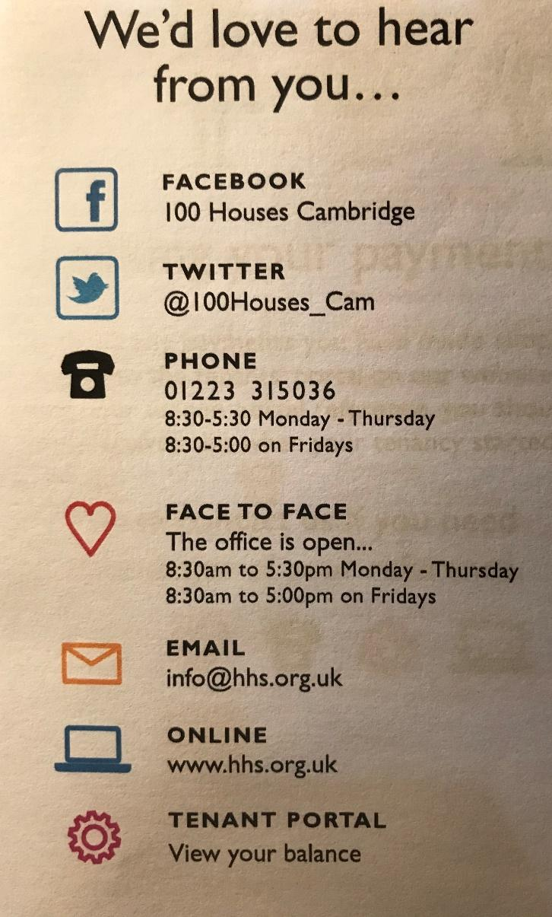

Cambridge City Council: 01223 457000
Customer Service Centre
Mandela House
4 Regent Street CB2 1BY
www.cambridge.gov.uk

Citizens Advice Bureau 0344 848 7979
(9.30am to 1pm – Mon to Fri)
66 Devonshire Road
Cambridge CB1 2BL
www.cambridgecab.org.uk

The Almshouse Association 01344 452922
Billingbear Lodge
Maidenhead Road
Wokingham Berks RG40 5RU
Email naa@almshouses.org
Website: www.almshouses.org

The Charity Commission for 0300 066 9197
England and Wales
Contact Centre open Mo-Fri 9-5
www.gov.uk/organisations/charitycomission

Housing Ombudsman Scheme 0300 111 3000
Exchange Tower
Harbour Exchange Square, Isle of Dogs
London E14 9GE
www.housing-ombudsman.org.uk
Email: info@housing-ombudsman.org.uk

Adopted 30 June 2023 by the Board of Trustees, next scheduled review 30 June 2026

